Alexandra Van Tuyll, Fundraiser and Supporter of GRCC.
Continued….
Alexandra was born in the Netherlands into a background of music and arts. She possesses a rare neurologic phenomenon called Synaesthesia which means the brain processes data in several senses at once. One sense activates another unrelated sense and both senses are experienced simultaneously. In Alexandra’s case, when she hears music, she immediately sees colours. As a trained classical pianist, Alexandra has a great love for music. Her love for music lead to colour which lead her to her love for art. Her talent has allowed her to meet many interesting people throughout her life. Alexandra stated that all artists are unique in their own way. Alexandra is a unique person, for many different reasons, however being that only about 4% of the world’s population experience Synaesthesia, there is no doubt this makes her work all the more interesting.
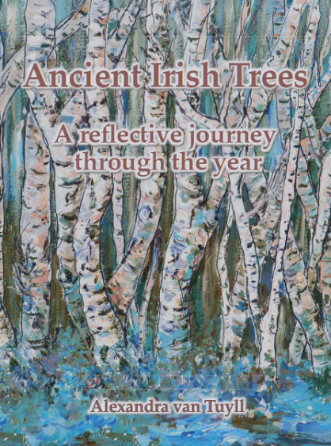
Alexandra moved to Ireland in the 1970’s but travelled widely prior to doing so. She lived in Indonesia for five years also, however due to the sharp light and severe heat, found it difficult to paint during this period of time. Mullingar was where she called home and ended up settling here for 25 years. Here she maintained a successful teaching career teaching Art, Music, and German Grammar. In 2001, she decided it was time to retire and begin a new chapter in her life. With an urge to live by the sea, Alexandra found herself venturing to the very west of Ireland and moved into a cosy cottage on the magnificent Achill Island, Co. Mayo. Shortly after moving, although she was now painting full time, she began looking for a new career and focus. She began to partake in many volunteering opportunities and events. Her volunteer work began with the RNLI Achill and from this she met several different individuals who had experience working with various organisations that sparked her interest. It was during this time Alexandra met a Galway Rape Crisis Centre employee. She had never previously considered the GRCC, however after learning more about the organisation, she believed they were a charity that needed help and were defiantly worth volunteering for. As she worked alongside the GRCC, she learned more about the services they provide, and her interests grew. She acknowledged the many challenges the GRCC faced and wanted to help increase their low profile.
Alexandra’s involvement with the GRCC lead to her wonderful project “Ancient Irish Tree’s”. A beautiful artistic book that takes us on a journey through the life cycle of thirteen native Irish trees, each tree being depicted in, winter, spring, summer, and autumn. She had just finished creating her successful book “Sea Meets Land” in support of the RNLI and was in search of a new project. The idea for “Ancient Irish Tree’s” came to her as she was driving home from a weekend spent with her daughter and family in Tipperary. The book is one of reflection and allows space for readers to record their own thoughts and reflections. The creation of this book was an extremely generous act from Alexandra as all proceeds from the sale of this book will be shared by the Rape Crisis Centres and Hospices in the West of Ireland.

The creation and publication of the book took five years. Alexandra began her process by studying the Celtic calendar. This was followed by drawings, painting and researching the poetry. All poems featured in the book are about nature. Nature is the overall theme of this wonderful creation and what Alexandra wants readers to take away from this book is the reverence of nature and identification with nature. She thoroughly enjoyed her experience whilst creating this book and encountered very little struggles and obstacles. She particularly loved the painting process and the poetry. Alexandra believes all Tree’s have character and I think this book is a testament to that. Her favourite tree is the Yew.
Alexandra continues to paint and is already brainstorming her next project. The Galway Rape Crisis Centre cannot express how grateful we are for her hard work and generosity. It was a pleasure to personally meet and thank Alexandra for all the work she has done. She is an inspiring individual who has used her talent and gift to help others and create a positive difference within this world. When asked what she would advise those considering volunteering and getting involved with charity organisations she said, “When you have time, look for where there is a need and where you feel happy to put your effort and energy into. Don’t waste your time sitting and just watching TV”. Her attitude is both motivating and encouraging.
I was saddened as our afternoon came to an end and Alexandra and I parted ways. However, I am so thankful I had the opportunity to meet with such an amazing woman. I look forward to seeing her future projects and creations.
