The following piece comprises of a series of questions and answers completed by the five students which organised Coldvember 2021. The piece provides an insight into what motivated individuals to participate, what participants gained from the experience and why Galway Rape Crisis Centre was a Charity worth fundraising for.

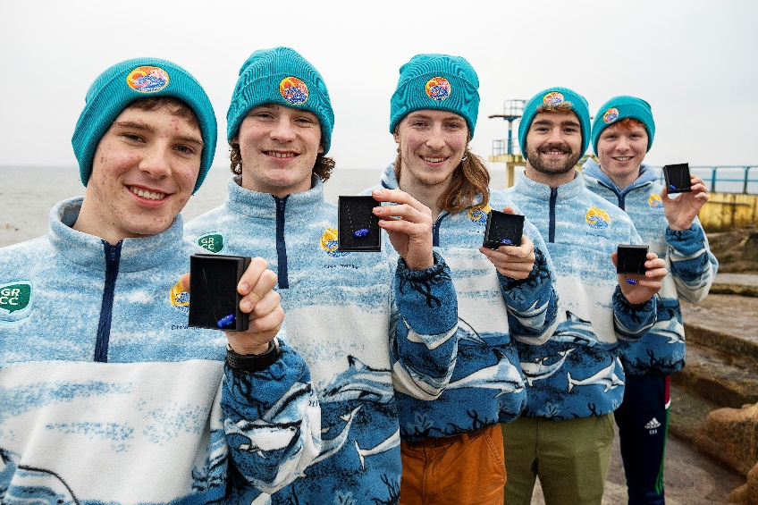

Q1. What was your motivation to become involved in Coldvember 2021?
Myself and a few friends regularly swim in the sea year-round and are very passionate abouts it mental, social and physical benefits. I myself have taken part in Coldvemeber since my first year in NUIG and witnessed first-hand the brilliant sense of community curated over the month whilst raising awareness and funds for great causes as well as promoting positivity. I really wanted to get involved in this fantastic cause and it just so happened that the wonderful girls who organised it in 2020 were looking for a group to take it on for 2021. So with that, I would say my main motivation to get involved in 2021 was the amazing work done by the previous organisers and the overall great vibe surrounding the entire initiative. -John Flannery

Q2. How did you hear about GRCC?
Before we started Coldvember, we had to come up with a charity to raise money for. After one of our weekly meetings, we all decided to go home and pick two charities and then come back and tell the group what they were (we wanted to keep the charity local). It ended up that 2/3 of us had picked GRCC and when we talked about it as a group, we knew that it was definitely the right choice. In previous years, Coldvember has raised money for mental health charities, but this year we decided to change it up and I’m so glad we did, as GRCC are a great organization that help people who have been sexually abused or who have gone through some sort of sexual trauma and allows them to heal by seeing and talking to the professionals who will get them through that tough time in their lives. - John Twomey
3. What made you want to fundraise for Galway Rape Crisis Centre in particular?
Once we were organised as a team to run Coldvember 2021, we held a meeting where we discussed what charity we wanted to fundraise for. As soon as the Galway Rape Crisis Centre was brought up, we were all in agreement that it was the charity that we wanted to dedicate Coldvember 2021 to. I think the reason we all wanted fundraise for the GRCC was due to the unfortunate number of stories of sexual violence we hear, in our community and online, that by raising whatever money we could, raising as much awareness, and spreading as much information as we could about the GRCC and the fantastic work it does, that we could actually make a difference and benefit the community. – Dan O’Connell

4. Did you learn more about the organisation by being involved with fundraising for it?
Yeah! Even before we chose the GRCC we made sure we knew what they stood for and the services they offered. We browsed through their website and social media, specifically their Instagram. Both are extremely informative whether you are seeking help, advice or are just trying your best to learn about the topic so you can try and understand. As 5 young men, this is a topic that is rife within our social groups. Having their informative pages and the amazing women at the organisation talk to us, we learnt a lot and we urge others to try and do the same - Charlie Clarke

5. What in particular stood out to you about this organization that you were not aware of before?
Everything about this organisation is remarkable, from their amazing information, services and the people themselves but what really stood out was their eagerness to get involved. It meant so much to us that the women at the GRCC came down and joined us for swims, were always open for a chat and really bought it the positive and fun atmosphere we tried to create. It really meant a lot to us and made us really feel apart of their efforts, something that made us all really proud - Charlie Clarke

6. Was raising awareness of GRCC’s services within your college and the wider community an important part of your partnership with GRCC during Coldvember?

Along with raising money for the GRCC, raising awareness was arguably the most important aspect of Coldvember. We felt like it was paramount that more people find out about this fantastic charity and it’s services. We achieved this by regularly posting information pieces about the charity on our social media and discussing the GRCC in every interview. The advantages for spreading the word about the GRCC are profound, as words cannot describe the benefits of having a supportive confidential organisation at your side in a time of crisis. - Eoin Hernon

7. Did you benefit from doing this fundraiser?
I think everyone who got involved over the month, benefitted from Coldvember, especially all of us in the “Coldvember Crew”. We had the amazing experience of forming a community of people who we would swim with and listen to music with, while raising money and awareness for the GRCC and the great work they do. We all developed a sense of pride for the community we created, and we benefitted from the support that they should in us. We enjoyed every minute of it, and so did everyone who joined us. – Dan O’Connell

8. Has being involved allowed you to develop new skills?
I would definitely say that this experience has allowed me to grow as a person, gain new skills and build on some of my skills. Within the group we shared the workload evenly, we all had certain jobs to do. My job was to talk with the businesses that were going to produce our beanies and fleeces and make sure they were done on time, that we received the right amount of them and that they were of good quality. Having the experience of working with a couple businesses like that, being on the phone to them making sure everything is going smoothly and then collecting and paying for the beanies will stand to me in the future. It’s great to have picked up on these new skills. - John Twomey

9. Would you encourage others to become involved with charity work?

We would encourage everyone to get involved in some sort of charity work in whatever way you can. Talking from our own experience and other people who came down in the mornings, there is a definite “feel good factor” after you engage in charity work as you can be proud that you are making a difference in your local community. - Eoin Hernon

10. What was the best thing about being involved in this event

Without a doubt the best thing about being involved in Coldvember 2021 was the overwhelming sense of community. It’s difficult getting out of bed at the crack of dawn with the thought of swimming in the freezing atlantic but knowing that there’s a great group of people in the same boat makes it a bit easier. And then, of course you rock down to Blackrock and it’s immediately worth it, everyone’s in flying form, smiles all around and we have the tunes going to lift the spirits a bit. We were so delighted that the regular Blackrock swimmers and dippers welcomed us with (socially distanced) open arms, we received amazing kind and encouraging words only spurring us on as the days got darker and the water got colder. But the highlight would have to be the last day of November, myself and the lads tipped down to the tower at 07:45 and the sheer volume of people was completely overwhelming. Pure euphoria. We have a fantastic picture on our Instagram of the absolute crowd of people that made the trek down that morning, and that kind of sums up the community that was created over the course of the month. University students who’d usually be culprits for lye-ins, in the freezing ocean at sunrise on a cloudy Tuesday with smiles on their faces helping raise awareness and funds for an amazing cause. - John Flannery

