STRATEGIC PLAN
2020 – 2025

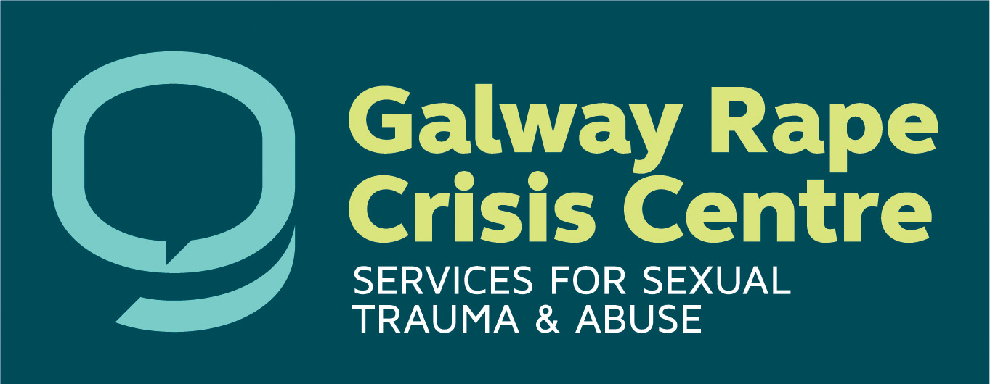

Table of contents:

Table of contents: 1
Our Mission 2
Background to the Strategic Plan 2
Our services: 2
Brief History: 3
Main priorities 4
Other ongoing priorities: 4
Priority one: New Premises 5
Actions and associated Outcomes: 5
Priority two: Clinical department: 6
Actions and associated Outcomes: 6
Priority three: Education department: 7
Actions and associated outcomes: 7
Priority four: Fundraising & Communication 8
Actions and associated Outcomes: 8
Fundraising 8
Communication & Engagement 9

Our Mission

GRCC is dedicated to providing a professional, caring, and confidential counselling and support service for those in our community affected by sexual abuse and sexual violence. We also work towards ending cultural and societal tolerance of sexual violence through advocacy, awareness raising and education programmes.

Background to the Strategic Plan

This Strategic plan uses the foundation stones set in our 2017 – 2019 plan. This project started many years ago when we gathered our board, staff and volunteers from the Centre and laid the foundation for this work.
GRCC has become the second largest Rape Crisis Centre in the Republic of Ireland, developing several services and actions over this time.

Our services:
- Crisis and longer-term counselling for male and female survivors, aged 14years upwards, of sexual abuse and violence, from our base at Foster court and our four Outreach centres: Ballinasloe, Tuam, Oughterard and Gort. Our client base come from Galway City & County, South Roscommon, and North Clare.
- Face to face Counselling, adapted during COVID-19 to include an Online video/telephone counselling service.
- Frontline freephone helpline service offering counselling/information and advocacy with other agencies on client’s behalf. Our Frontline service continues to grow, dealing with increased numbers year on year, and COVID-19, has added greatly to the demand for our care and support.
- Short term counselling for Supporters of survivors.
- Education and prevention programmes. The new Education Department in GRCC will shape responsive education and training programmes and practices which are informed and underpinned by the needs of survivors of sexual violence. It is our hope that through these programmes we can help people to understand the impact sexual abuse and violence has on victims’ lives. We also hope to enable a more open and informed discussion about sexual violence and abuse and the subject of consent.

- Disclosure training and Awareness raising for colleges, businesses, and other groups.
- We operate an on-call Psychological support service to the Sexual Assault Treatment Unit, SATU.
- In collaboration with the Gardai, we offer Court accompaniment to survivors.
- In-house Garda accompaniment services.
- Support with the preparation of Victim impact statements where required.
- Free monthly legal clinic.

Brief History:

Our organisation has had to withstand a devastating economic recession that challenged the entire voluntary and community sector in the past 10years.
Then 2020 brought the impact of COVID-19, which no one could ever have foreseen and challenged us to continue to deliver our service in a different way. We adapted and rose to the challenge without shutting our doors, thanks to our staff who have worked unerringly towards achieving that goal, through their professionalism, compassion, and commitment to both our long term and recent survivors of sexual abuse and assault.
We have witnessed significant societal change over this time. Ireland has become more diverse as a society, in some ways more tolerant of difference yet also more fragmented and discohesive. However, we are hopeful as we look ahead into the next five years, that together we will build an even stronger service, and do our best to ensure that all survivors of sexual violence and abuse will be the better for their interaction with our team at the Galway Rape Crisis Centre.
We also embrace the challenges that this report has presented.

Main priorities

We have chosen these four main priorities from the plan to guide us during the next five years.

- New premises for the Galway Rape Crisis centre, in order to maintain the long-term future of our growing services.

- Clinical Department; The way in which we coordinate our actions, organise ourselves, and work together will determine how effective we are in hearing and responding to client needs and preferences.

- Education Department; The overarching goal of our preventative work is to challenge societal norms, reduce stigma related to sexual violence, and advocate on behalf of survivors of sexual abuse and violence. To also become a key service provider regionally in education, training, and community attitude change.

- Fundraising department; five-year strategy to increase funding is critical to achieving the service innovations referred to in the strategy, or even to meet existing community needs. Enhance the visibility of GRCC in the local community and with community/ statutory stakeholders.

Other ongoing priorities:

- Database: to streamline our statistic gathering so it reflects our needs as an organisation and the needs of our funders.

- Update and enhance our GRCC Information technology requirements to improve our service delivery and enhance communication between all staff, as well as creating a one-stop Staff portal, through sharePoint ensuring the latest risk free data sharing.

Priority one: New Premises

Our service has grown significantly over the last number of years and continues to expand. This has highlighted the need for a permanent home for our service. A place where both Counsellors and our Clients feel secure and safe, when both working there and visiting. We own a building in Claddagh Quay and our goal is to demolish the existing premises and to establish in its place a purpose-built centre to service the people of Galway, North Clare, and South Roscommon.

Actions and associated Outcomes:

The following are the main actions that will progress our work
finding new premises for our Galway RCC service:

- Continue to seek planning permission for the design and redevelopment of The Claddagh as a new home for GRCC services.
- Communicate widely, making our need for Capital funding known to influential people in the greater Galway area, local press and radio, local businesses, and philanthropists.
- Use our Fundraising strategic plan to assist with the costs of relocation.

Responsibility for Leading this Action will rest with:

Executive Director and the Chairperson with support of the Board
in terms of oversight.

Priority two: Clinical department:

Clinically Galway Rape Crisis Centre has, over the past 12 months met the challenge of COVID-19 in a creative and responsive manner. The challenge of COVID-19 has brought the clinical team on a strong learning curve as we moved to the provision of online counselling/psychotherapy in totality initially. As we, along with the nation, grappled with various levels of restrictions we also introduced a blended approach as regards counselling sessions working both remotely online and in the Centre face to face, where possible.

Strategically the Clinical priority in the short to medium term is to continue to professionalise the service with refresher training for all the team on the various policies and procedures under development. In addition, prioritising creative solutions to addressing the waiting lists in both the Adolescent Clinic and Adult Counselling Services.

Actions and associated Outcomes:

The following are the main actions to ensure the continued provision of professional and quality services and supports:

- Maintaining outreach services in the Community to better facilitate clients to avail of support who may have difficulties with travel to Galway City.
- Support the SATU accompaniment service and Court Accompaniment services.
- Ongoing policy updates, clinical and organisational.
- Maintaining waiting lists at a manageable level.
- Human resources management and Development; staff wellbeing is key to continued provision of key services.

Responsibility for Leading this Action will rest with:
Clinical Manager with support of Executive Director

Priority three: Education department:
Prevention and awareness have always been an integral part of GRCC’s ethos. GRCC is dedicated to providing education and training on the issues of sexual violence. We have provided training to groups and organisations in the community. Through the years we have developed strong partnerships with other organisations such as NUI Galway, the Lifes2goodfoundation, CYSPC and Tusla. The collaboration process has taken many years but continues to grow in strength.

Actions and associated outcomes:

The following are the main actions that will develop the aims of our Education department:
- The Education Department in GRCC will shape responsive education and training programmes and practices which are informed and underpinned by the needs of survivors of sexual violence.
- The Education Department will work towards building a whole of society response to sexual violence through firstly providing training for professionals whose role means they engage with survivors of sexual violence, and then members of the public in general.
- The Education Department in GRCC will continue to build relationships and links with stakeholders and agencies in the community.
- Collaborate with other groups and organisations on ideas and projects which will further the aims of the Education Department.
- Use social media as a tool to educate and inform about Sexual Violence, and the activities of the Education Department, by developing specific targeted content and campaigns.
- Continue to connect and develop relationships with secondary schools in County Galway through our partnership with the EU commission and Tusla and the potential work with Pavee Point.
- Continue to ensure the Trainings we provide are in line with best practice, review and update training materials regularly and thus ensure that the Training objectives are met.
- Identify gaps in Training Provision around Sexual Violence and develop strategies to fill these gaps.
- The Education Department will ensure all GRCC education and training providers are equipped with the skills necessary to provide a quality learning experience.
Responsibility for Leading this Action will rest with:
The Head of Education and Training and the Education Coordinator, with support of staff in the delivery and oversight of our Executive Director.

Priority four: Fundraising & Communication

The emergence of COVID-19 in early 2020 had a detrimental effect on fundraising for GRCC. Governmental regulation meant the cessation of community-based events which was the focus of the vast majority of GRCC’s fundraising at that time.
Strategically GRCC will diversify into new and varied streams of fundraising, to ensure over-reliance on a particular fundraising stream does not occur. These varied streams will be characterised by short term, medium term and long-term outcomes.
Continuing to build and nurture a strong presence in the community is key for GRCC. We will increase our visibility in the community with our presence across multiple media platforms including radio and print, with the intention of raising the profile of GRCC as a credible and trusted source of information about sexual violence in our local community.

Actions and associated Outcomes:

The following are the main actions that will progress our fundraising and communications work for GRCC’s services:

Fundraising
Diversify and expand GRCC’s funding streams in order to maintain and develop a sustainable financial base for our work.
- Continue to further develop online Fundraising Campaigns using external platforms, and GRCC’s social media platforms.
- Secure support from corporates.
- Strategically expand GRCC’s fundraising portfolio in the context of sustainability.
- Utilise resources presently available to GRCC.
- Strategic collaboration with other not for profits.
- Steward and nurture current relationships and partnerships within the community
- Continue to access philanthropic opportunities - grants, trust, and foundations in a strategic manner.
- Develop a donor database.

Communication & Engagement
Implement a coherent and comprehensive communications plan.
- New telecommunications systems: GRCC will install a new telephone system to streamline communications within our centre and work more effectively for our Helpline.
- Website: overhaul of GRCC website to reflect the needs of our stakeholders to support and showcase the work of GRCC. Use of analytical tools to ensure optimisation of our website.
- Social media: Our social media channels are instrumental in disseminating GRCC’s key messages. Increase GRCC’s footprint across all media platforms using analytics, tracking, and upskilling of staff.
- GRCC will incorporate a secure system, such as SharePoint, to share resources within the organisation.
- Proactively find ways to publicly talk about GRCC’s service and promote it at strategic events and to specific influential people.
- Develop a strategy to comment proactively and carefully around topics of relevance to our service in both the national and local media.
- Developing relationships and ensuring that we communicate our capabilities and openness to collaboration within the sector.

Responsibility for Leading this Action will rest with:
Fundraising & Communications Manager with support of staff in the delivery and oversight of our Executive Director.

